Parkview Adventist Academy

1st and 2nd Grade

2025-2026 School Supply List

* 2 24-Pack Crayons 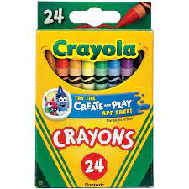
* 2 Packs Markers 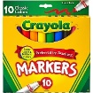
* 1 Pack Colored Pencils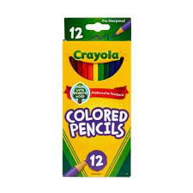
* 1 12-Pack **Erasable** Colored Pencils 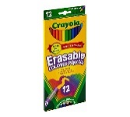
* 12 Yellow Pencils 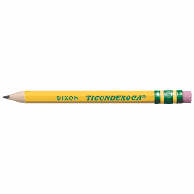
* 2 Large Pink Erasers 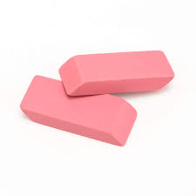
* 8 Glue Sticks 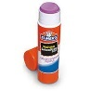
* 1 Bottle White Elmer’s Glue 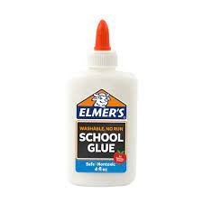
* 1 Box Watercolors 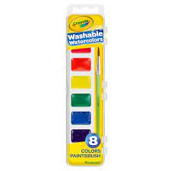
* 1 Pair Blunt Children’s Scissors 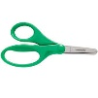
* 2 Plastic Pencil Boxes 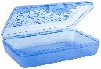
* 1 Pair Headphones (No Bluetooth, Please) 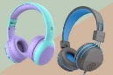
* Water Bottle with Straw or Narrow Opening 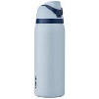
* 2 Containers of Clorox or Lysol Wipes 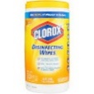
* 1 Ream Copy Paper 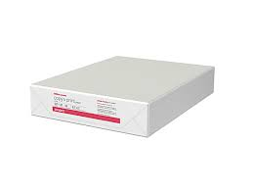
* 2 Boxes of Tissues 